D-311 Unit 3: Radios

Course Objectives:
By the end of this course students will be able to:
- List three steps of clear and concise radio communication
- List five standard radio traffic priorities
- Identify frequency types and radio systems
- Describe five methods of frequency management
- List and describe three types of frequencies used for aircraft

Unit at a Glance:
Unit | Topic | Approx. Time
Unit #: Unit Name | This unit allows participants to learn about their peers in the class and become familiar with course goals and objectives. | # Minutes
Unit #: Unit Name | This module provides a brief review of … | # Minutes
Unit #: Unit Name | Example Topic | # Minutes
Unit #: Unit Name | Example Topic | # Minutes
Unit #: Unit Name | Example Topic | # Minutes
Unit #: Unit Name | Example Topic | # Minutes
Total Time |  | Total # Minutes

Course Materials:
- IRPG
- Laptops/desktop

Classroom:
- Ability to display images and video on large screen.

Slide 1
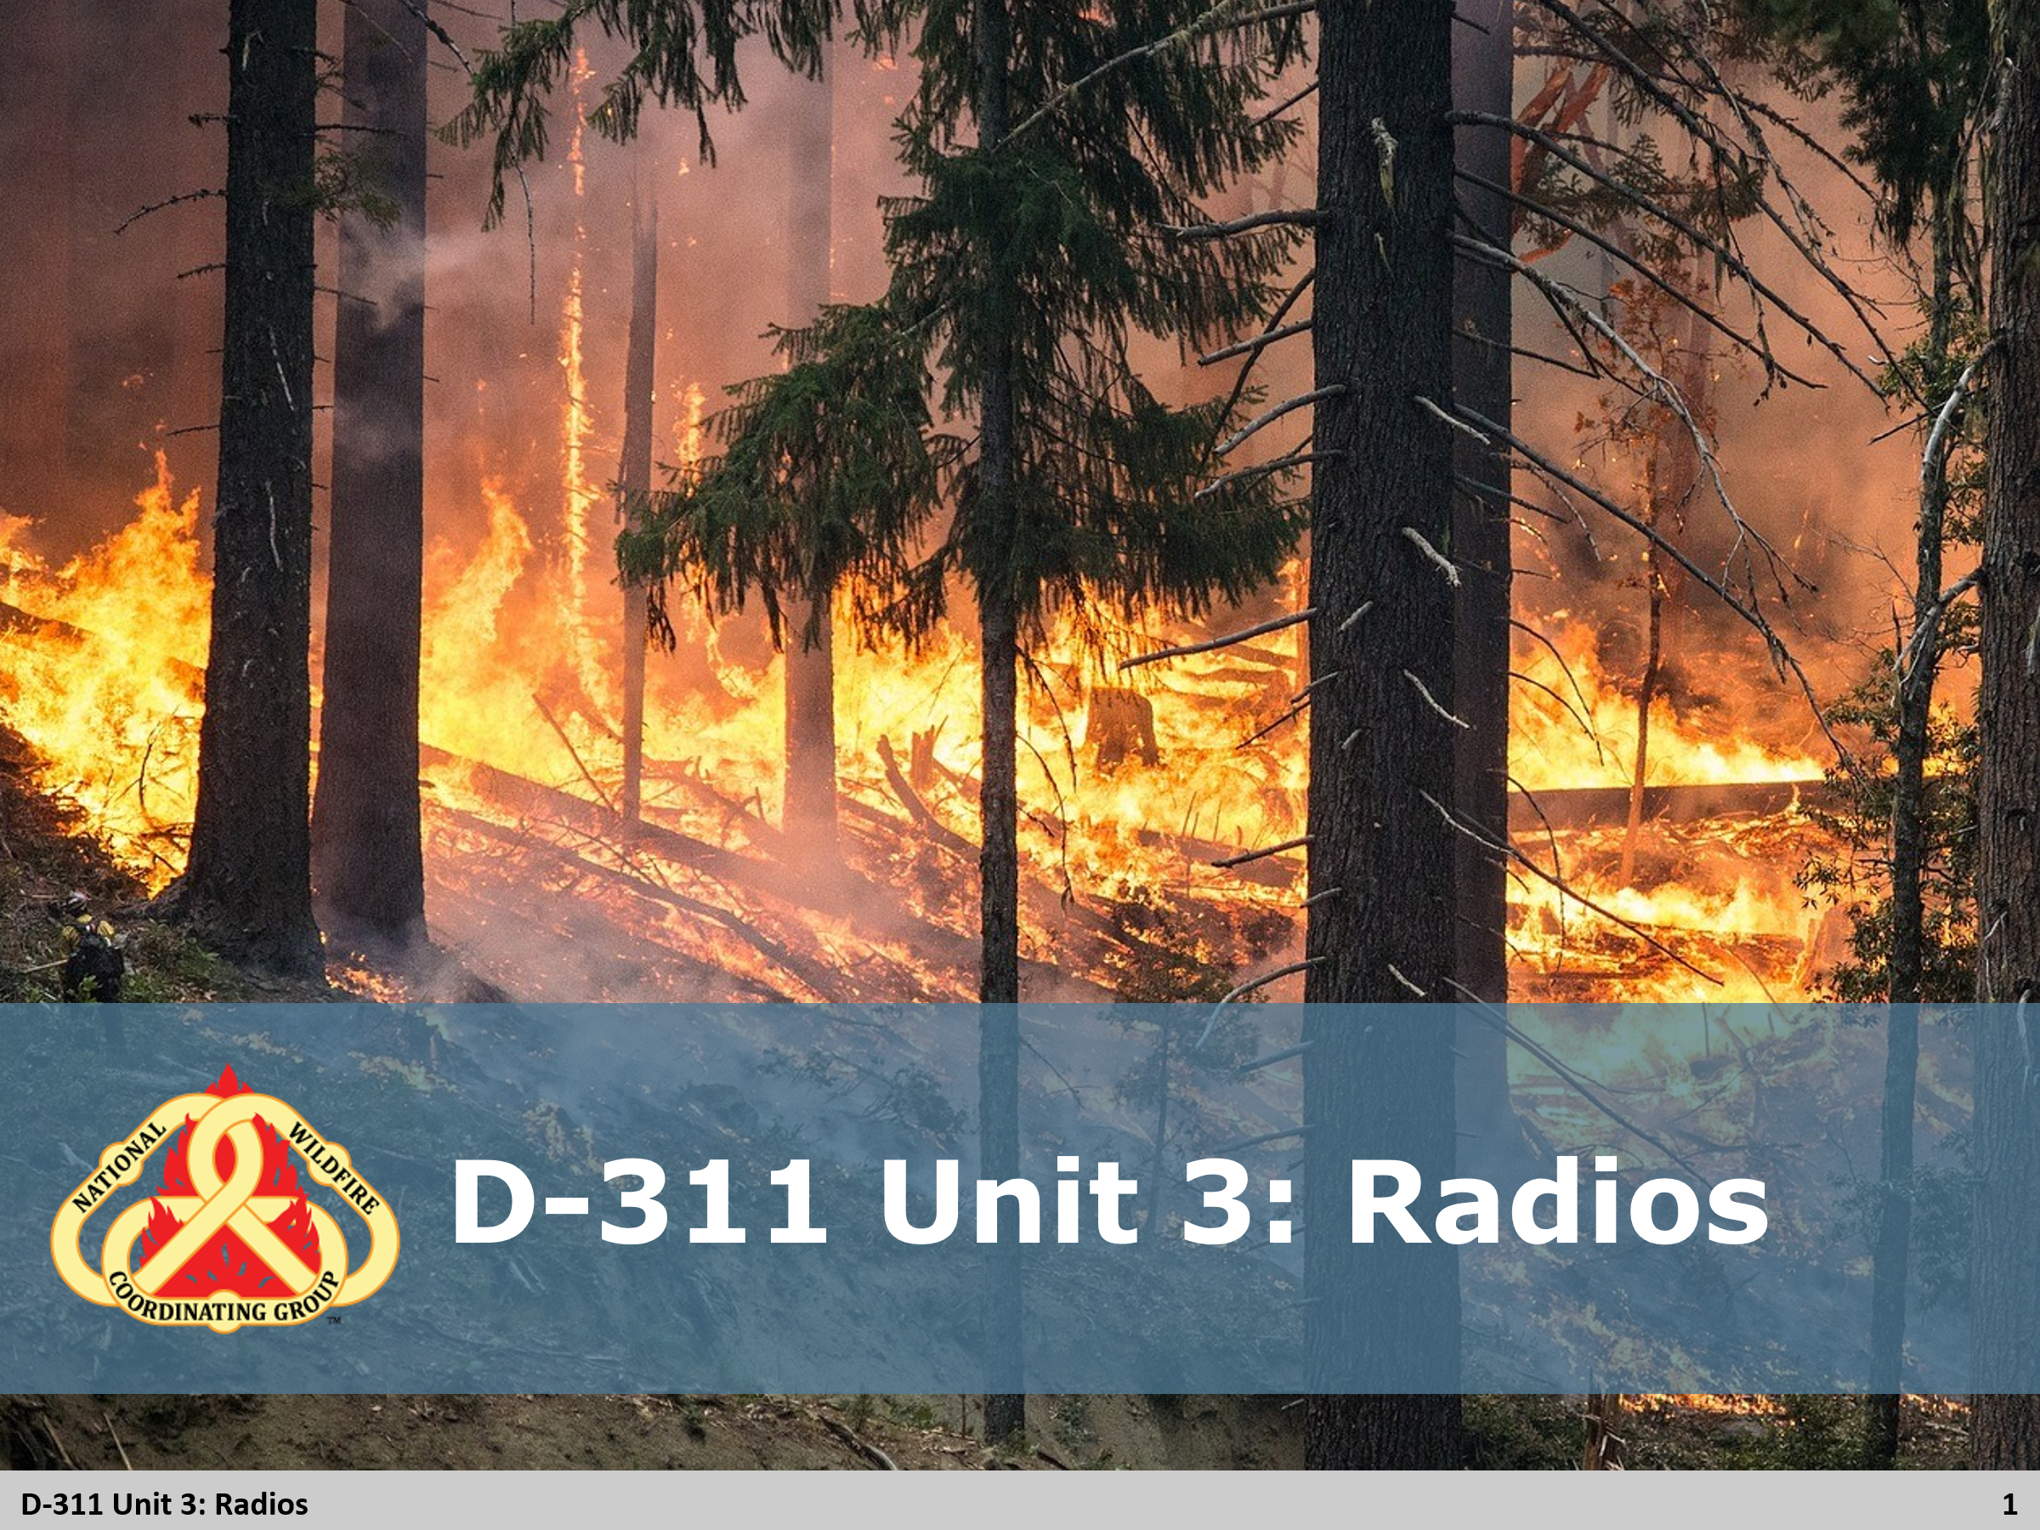

Slide 2
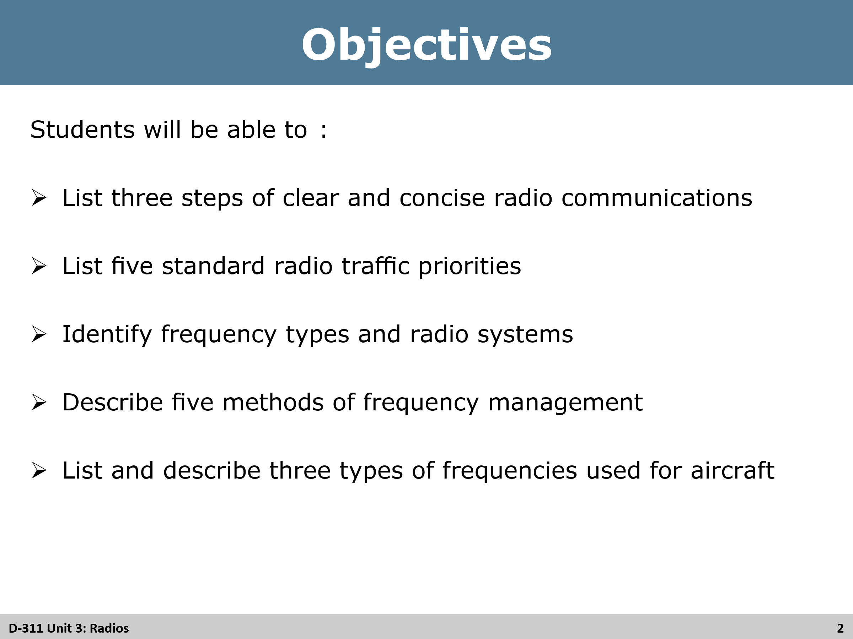
Review Unit Objectives
By the end of this unit, students will be able to:
- List three steps of clear and concise radio communications
- List five standard radio traffic priorities
- Identify frequency types and radio systems
- Describe five methods of frequency management
- List and describe three types of frequencies used for aircraft

Slide 3
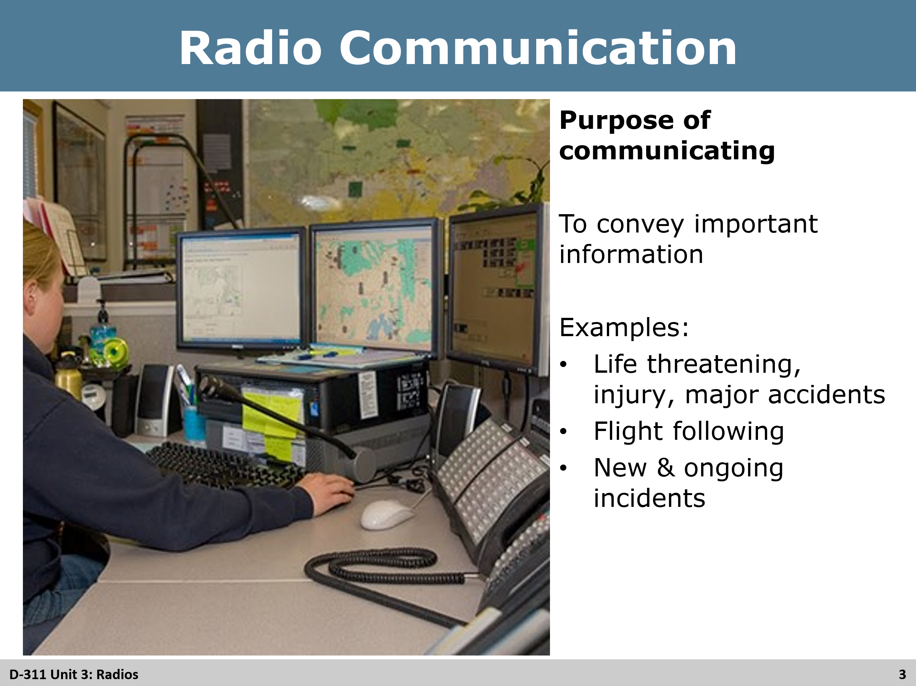
Review
Purpose of communicating
- Ask students to give examples
- Show and discuss other examples with students
  - Life threatening
  - Injuries
  - Major accidents
  - Firefighter and public safety are always the first priority
  - Flight following
  - New and emerging incidents
  - Ongoing incidents
  - Administration

Slide 4
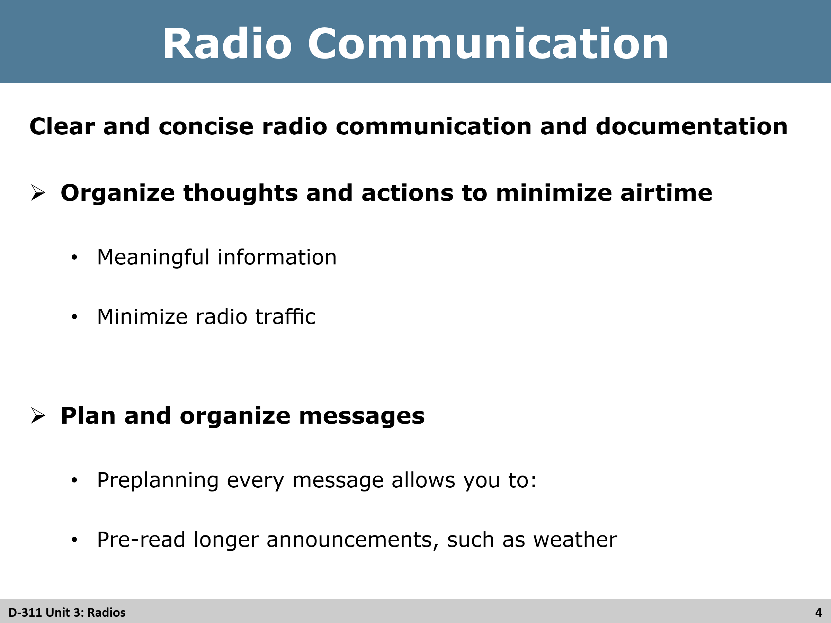
Review
Organize thoughts and actions to minimize airtime (ask students for example of what to think about before transmitting).
- Meaningful information
- Unneeded chatter
- Minimize radio traffic
- Do not say “I don’t know” and do not think out loud on the radio. Instead say “stand by” if the unknown answers to questions that come over the radio.
Plan and organize messages (ask students what to think about when planning their messages).
- Explain that, if you don’t understand what you are saying, the person you are talking with will not understand what you are saying either.
- Preplanning every message allows you to: (Ask students for examples for preplanning messages)
  - Organize thoughts
  - Ensure you have complete information to pass at one time

Slide 5
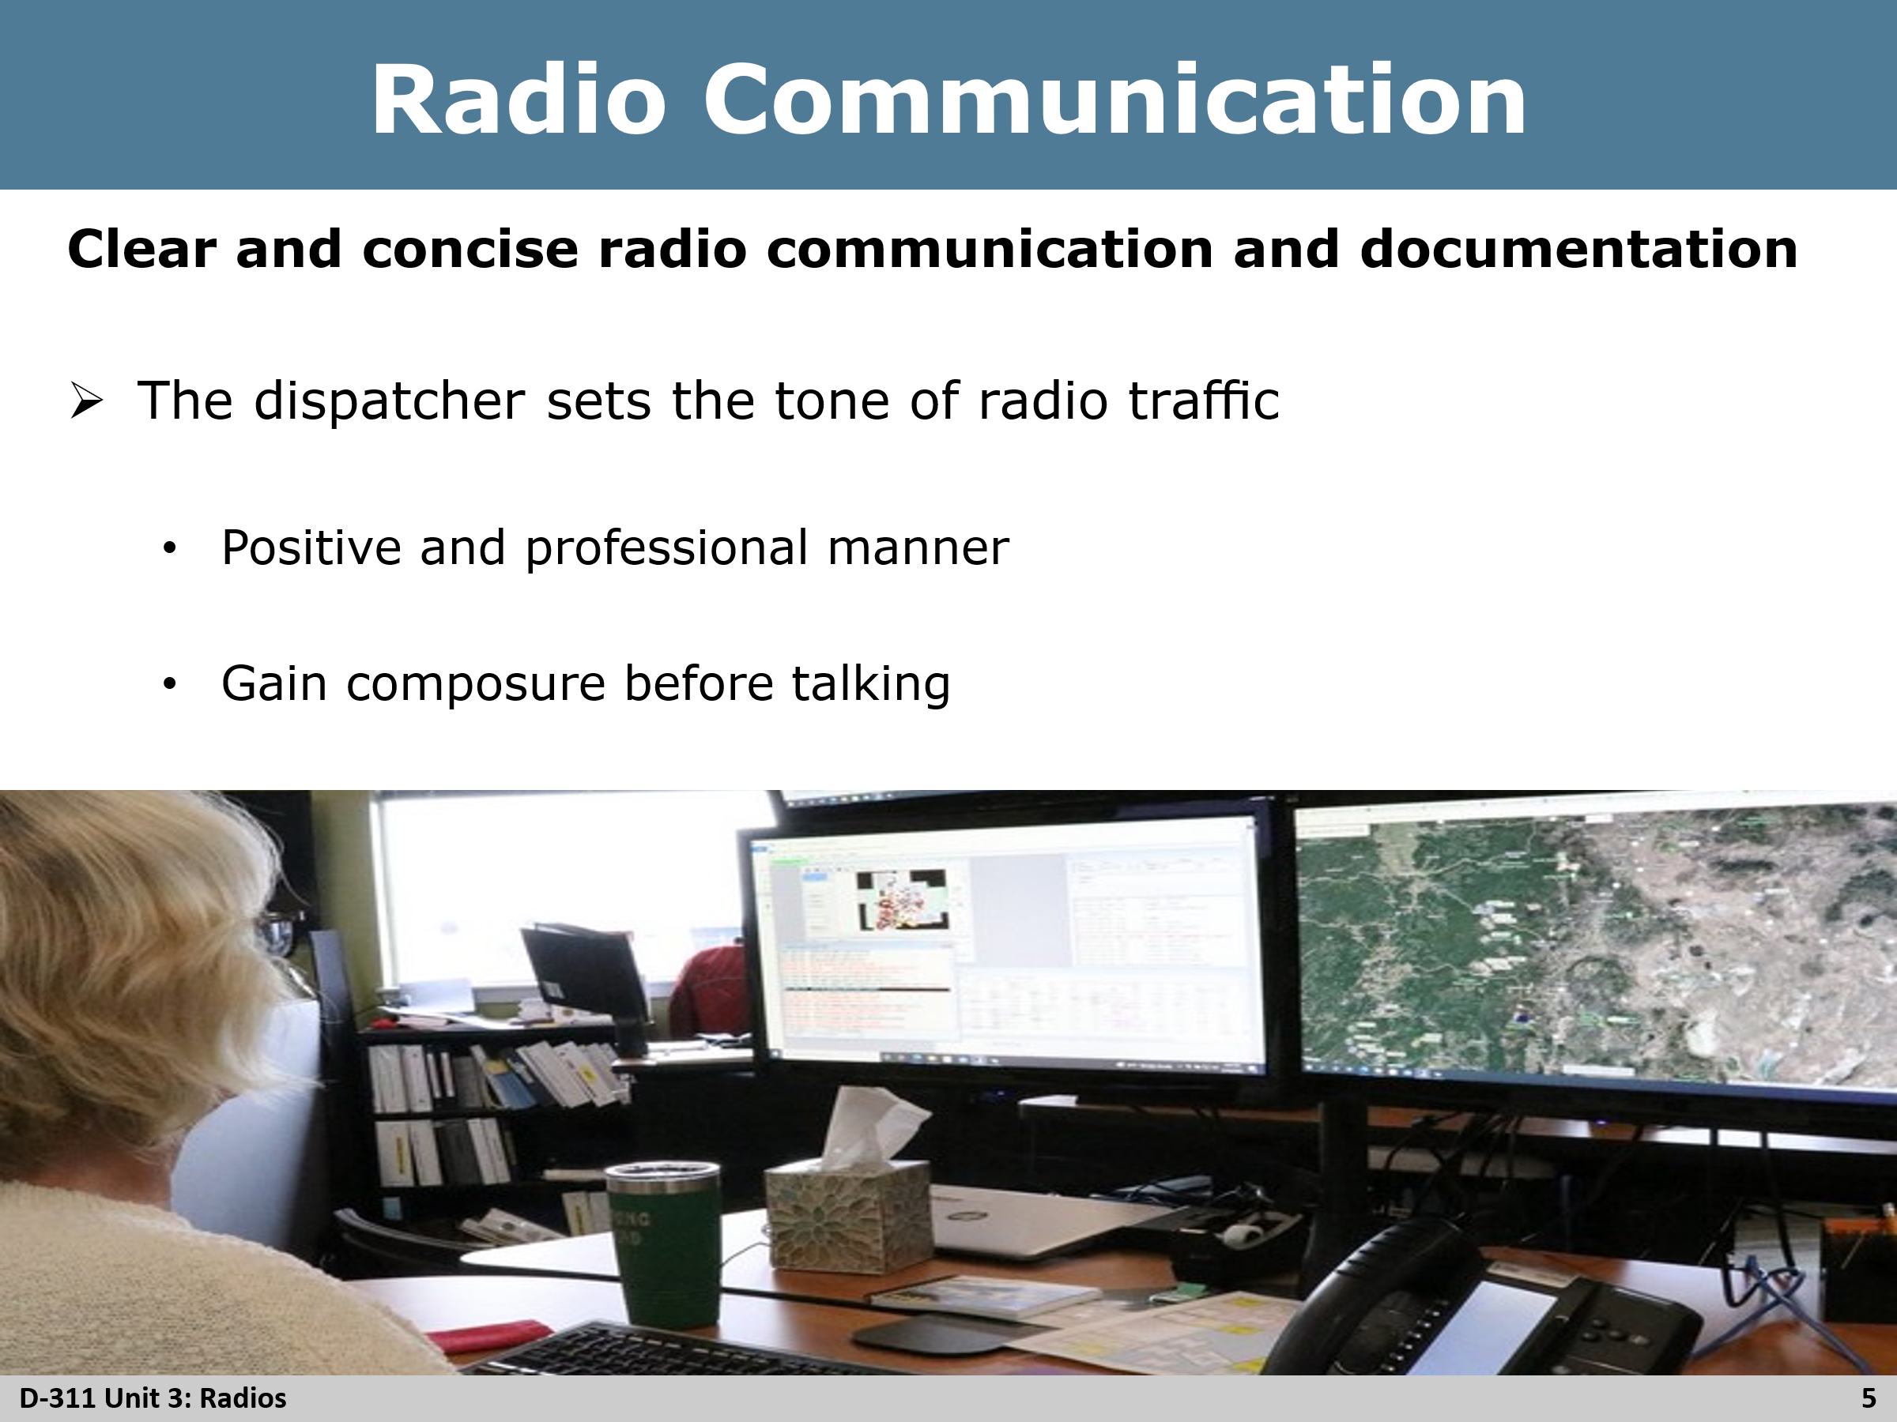
Review
The dispatcher sets the tone of radio traffic
- Positive and professional manner
- Do not say anything confidential or disrespectful on the radio. Anyone can be listening
- Do not use offensive language
- Gain composure before talking
- Avoid raising the stress levels of those listening
- Do not use patient names over the radio for medical incidents

Slide 6
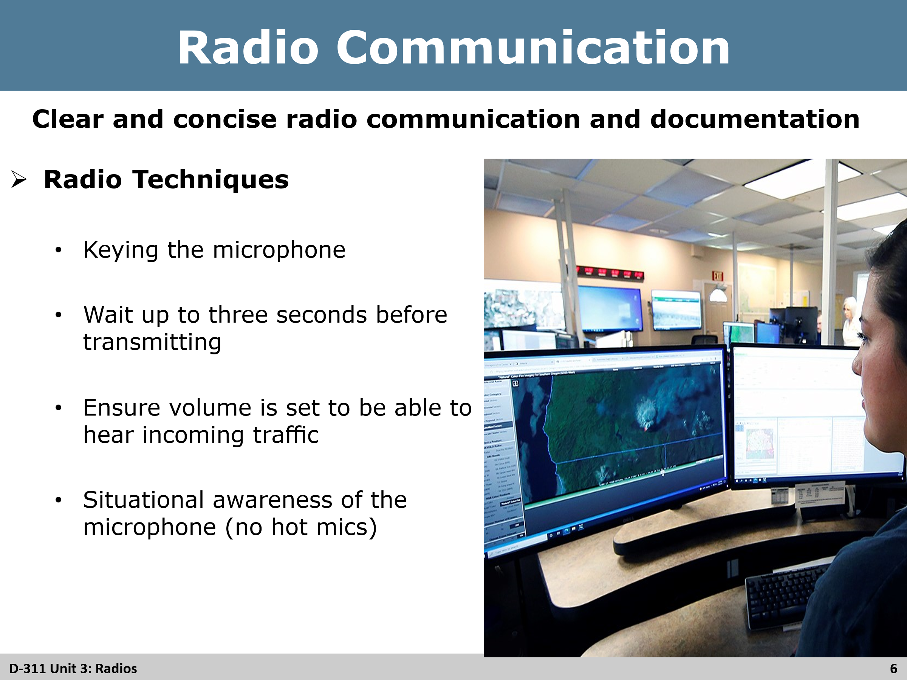
Review
Radio techniques (have students give examples before showing the rest).
- Keying the microphone for transmission
- Wait up to three seconds after keying before transmitting, explain why we wait
- Ensure volume is set at a reasonable level to be able to hear incoming traffic
- Situational awareness of the microphone (no hot mics)
- Transmitting both receiving and transmitting identifiers
- Transmitting the FCC radio system identifier(s)

Slide 7
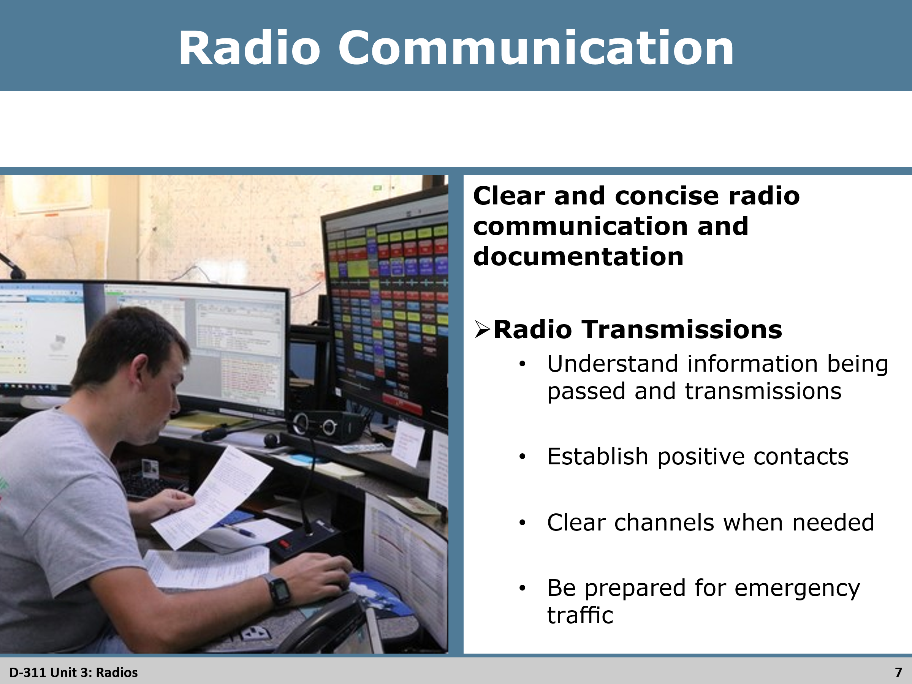
Review
Radio Transmissions
- Understand information being passed and transmitted
- Copy – when you have understood the transmissions
  - Don’t always rely on playback function of the radio
- If message it is not clearly understood, be sure to ask sender to “repeat” for a clear understanding of the transmission
- Establish positive contact
  - Do not transmit in the blind
- Confirm to copy for long messages
  - Helps avoid having to re-transmit
  - Red flag warning
  - Weather / spot forecasts
- Clear channels when needed for radio traffic
  - Emergency traffic
  - Restrict channels as needed and remember to un-restrict when no longer needed

Slide 8
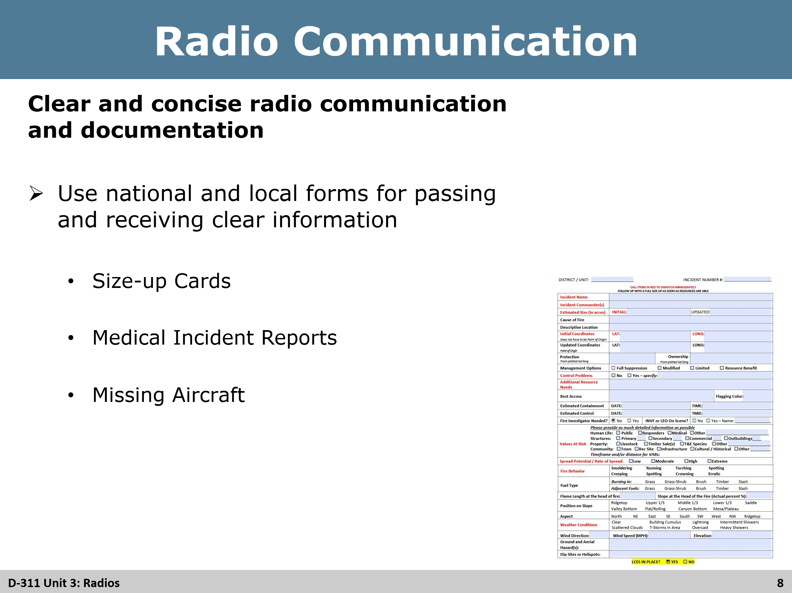
Review
National and local forms
- Ask students if there are any they know of before moving on
- Size-up cards
- Medical Incident Report
- Missing Aircraft

Slide 9
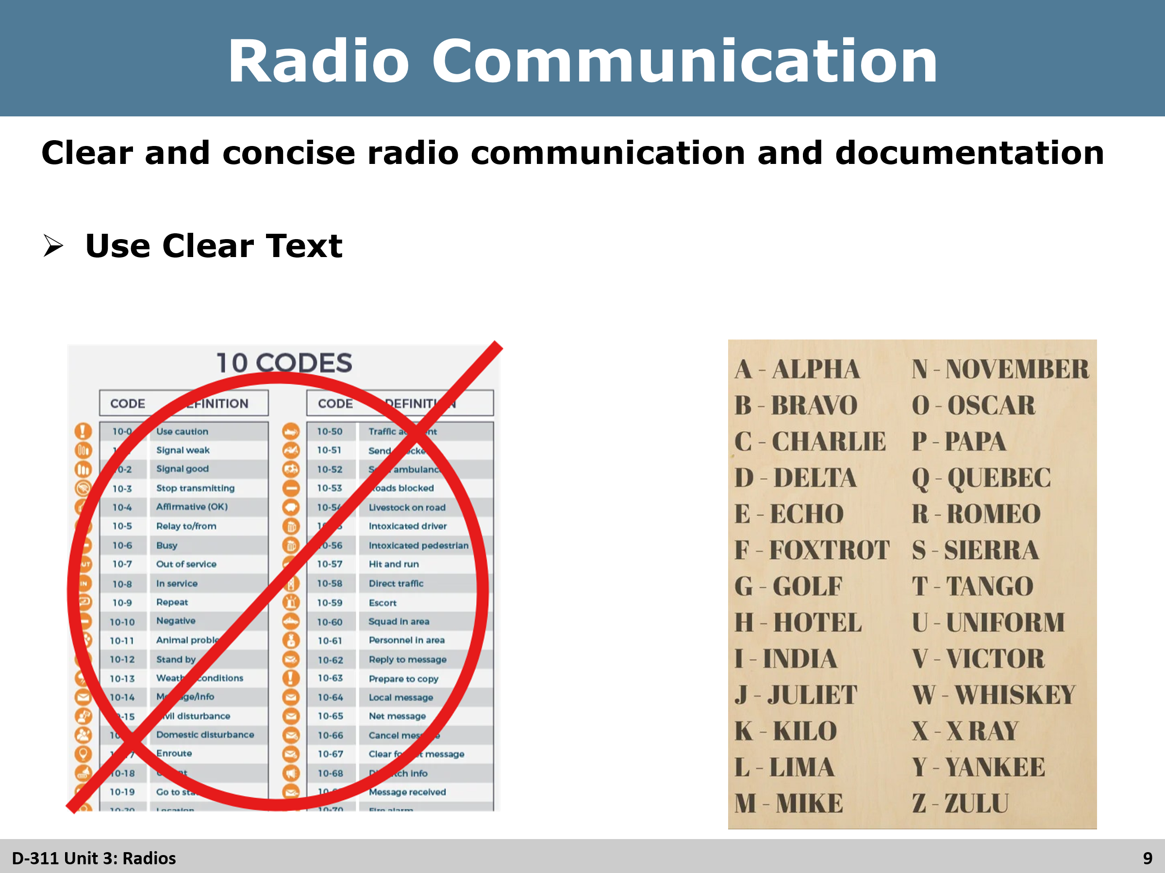
Review
Clear Text
- Explain why clear text is important
- No 10 codes
  - 10 codes don’t match up nationally
- Use of the phonetic alphabet

Slide 10
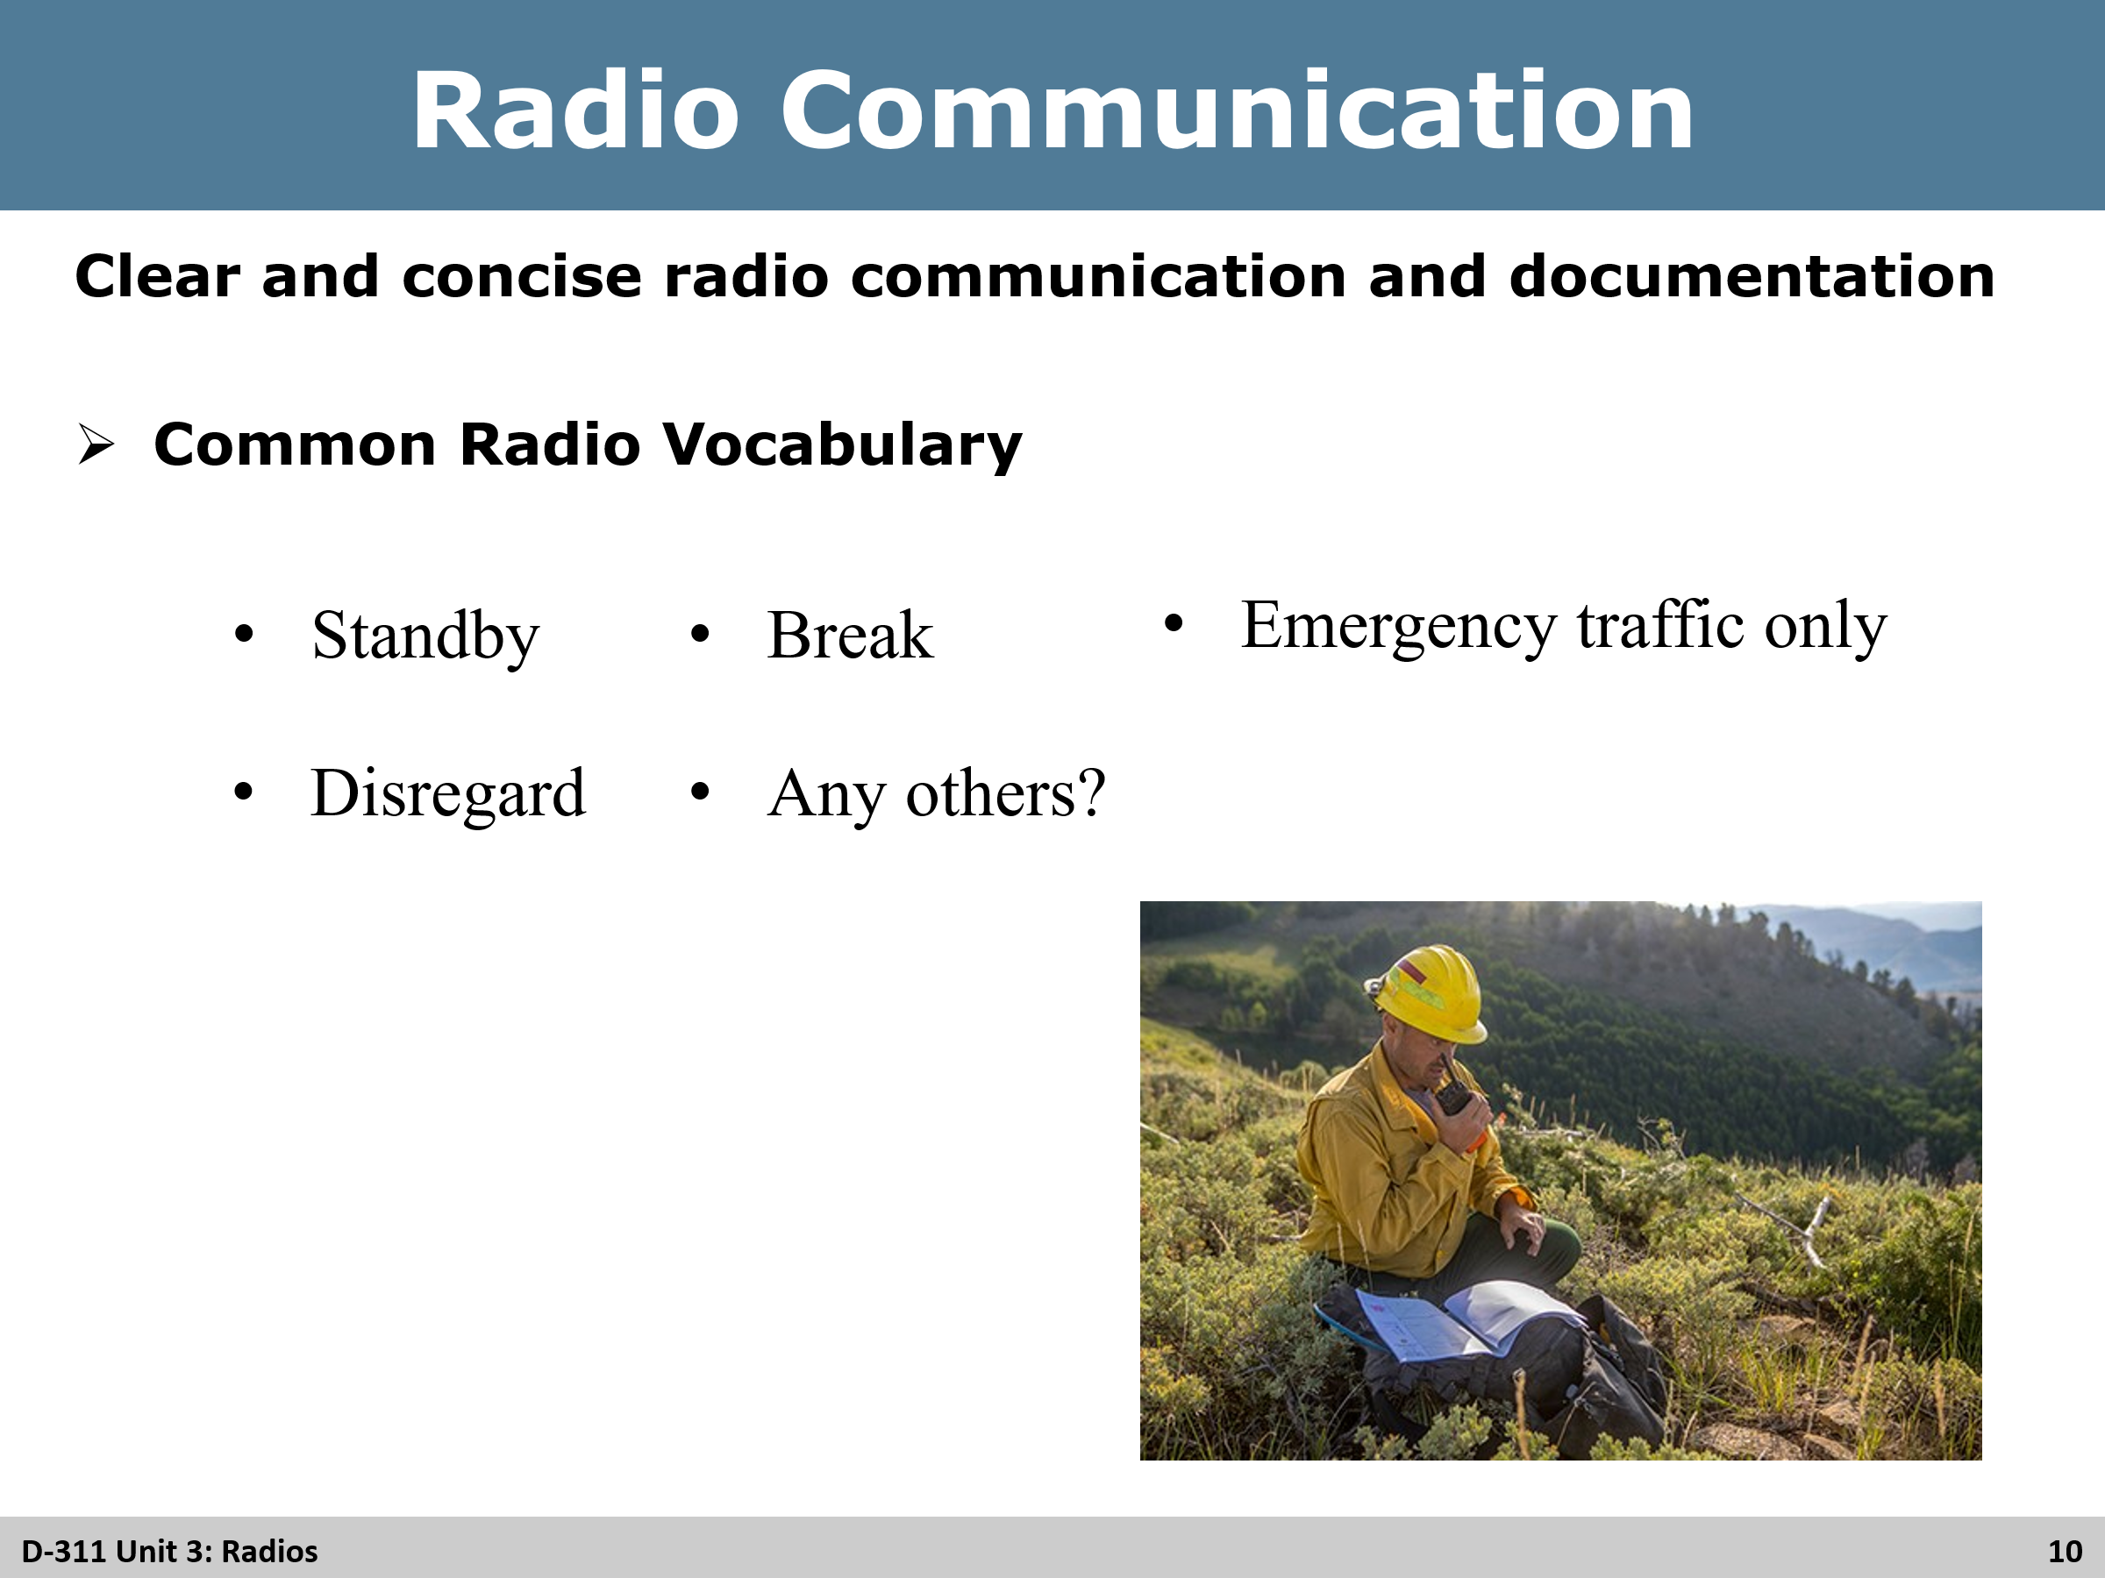
Review
Common Radio Vocabulary
- Ask students if they can think of any common vocabulary to use over the radio
  - Standby – I will get back to you
  - Break – brief stop in traffic
  - Unreadable – not able to understand transmission
  - Emergency traffic only – hold on any non-emergency traffic
  - Resume normal traffic – un-restricts radio traffic
  - Disregard

Slide 11
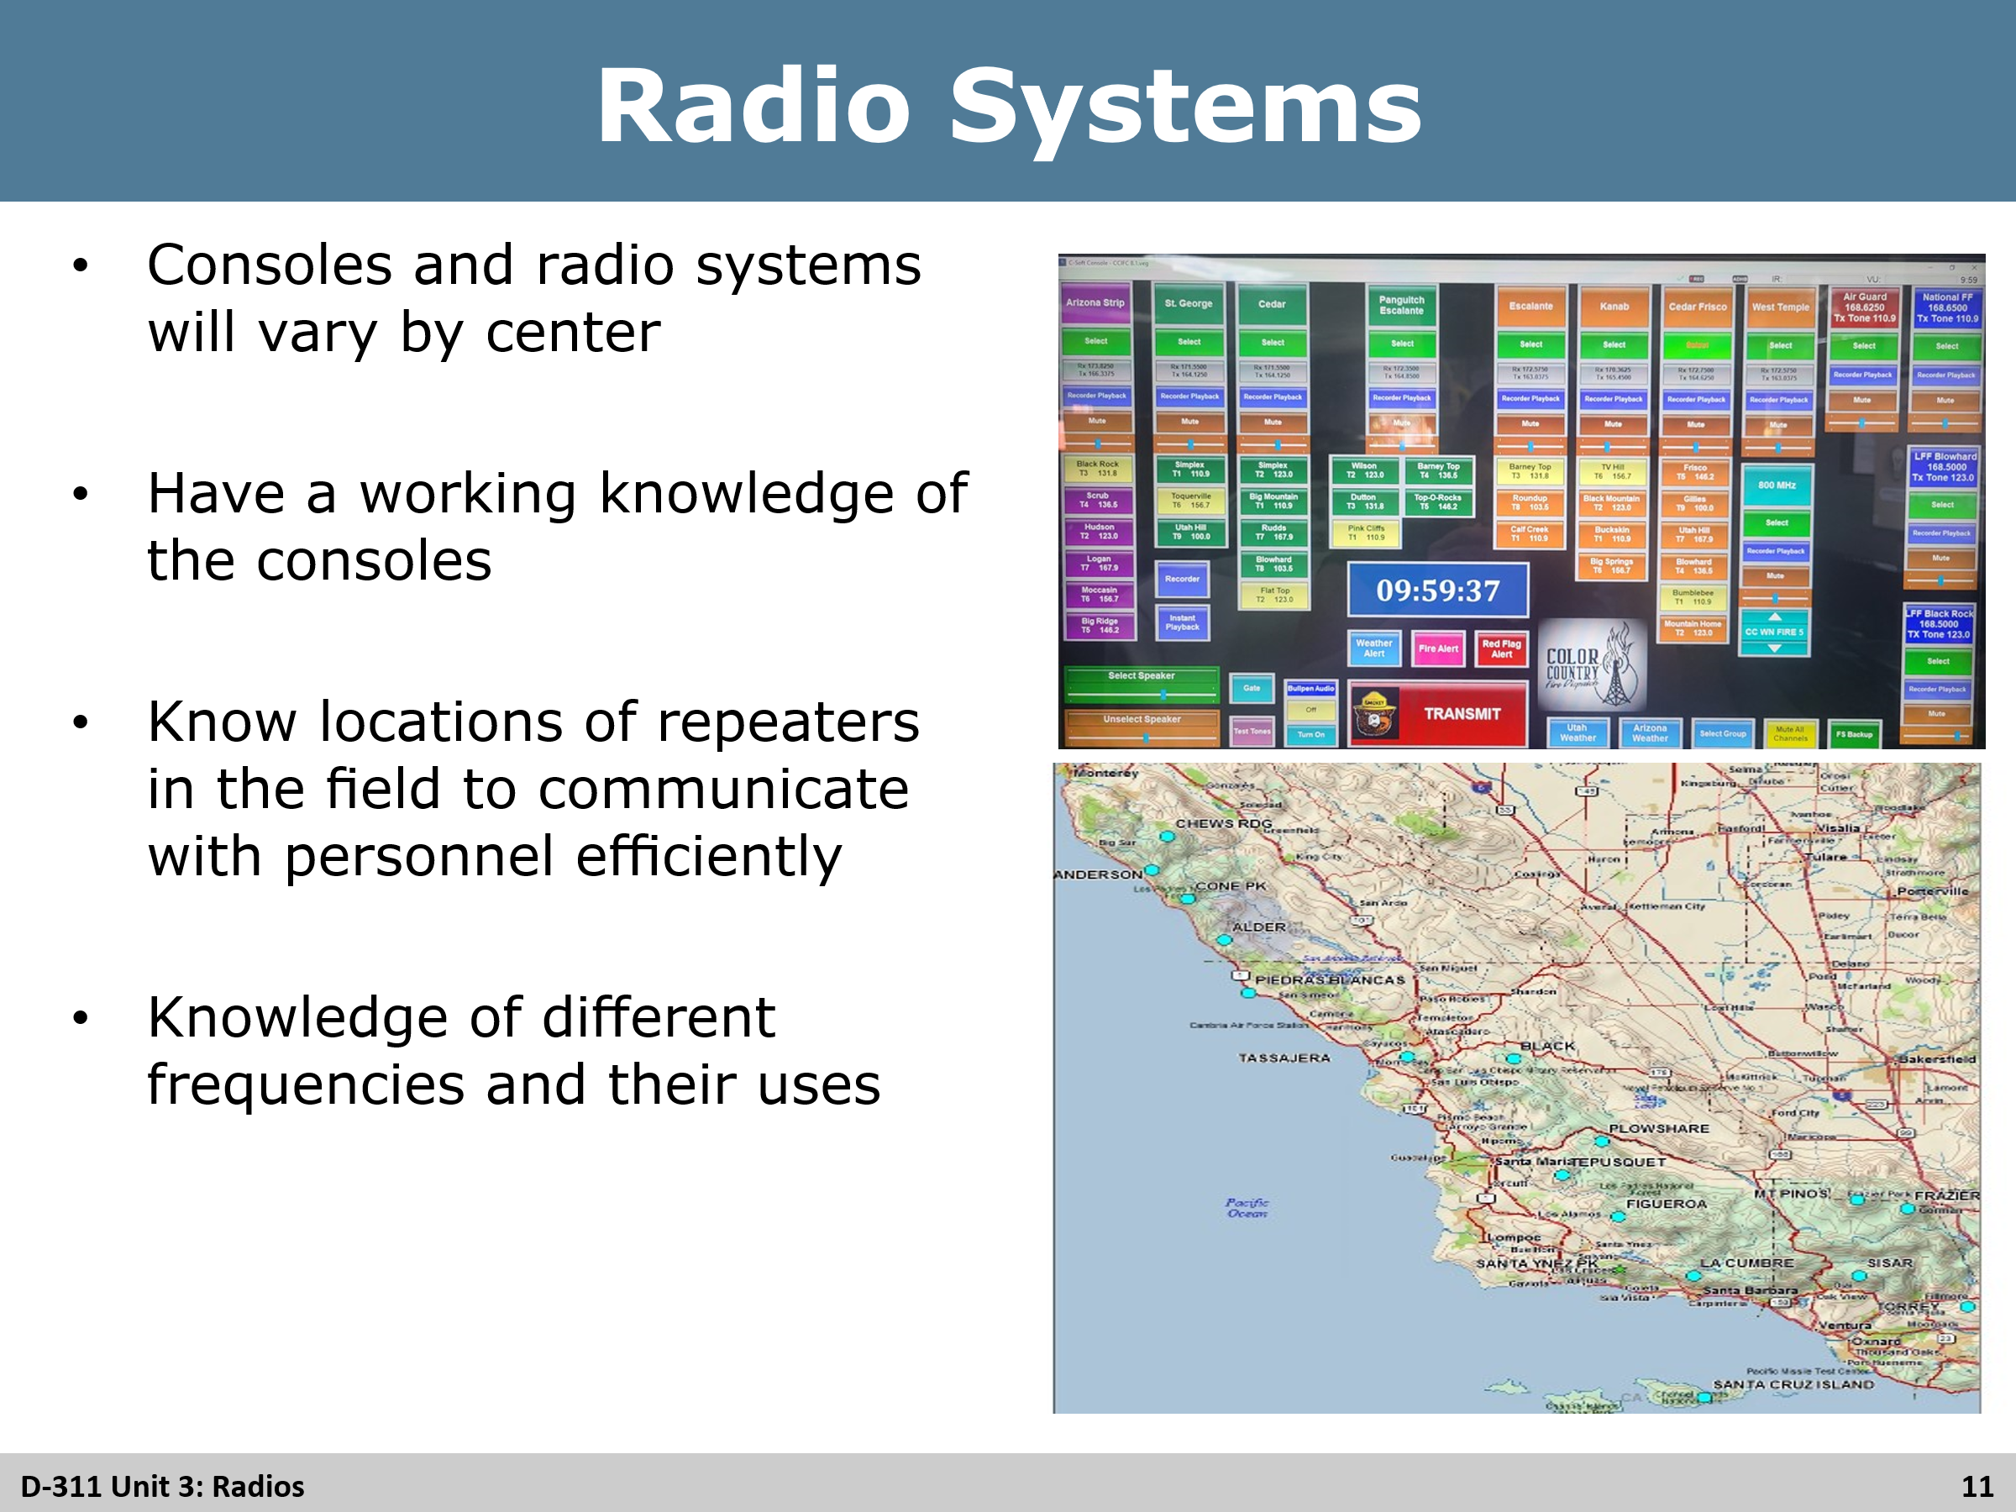
Review
Radio Systems
- Explain to students that radio systems and consoles will be different at just about every center they go to
- Dispatchers must know and understand their equipment and capabilities of the system they are using
- Know how to select proper frequencies on the console
- Must know locations of base stations and repeaters to be able to effectively communicate with field personnel (explain radio coverage maps)
- Shared frequencies (some centers have shared frequencies with federal, state, and local cooperators)
- Administrative frequencies (In service, out of service calls. Typically, not used for emergency traffic)
- Explain who to contact with any radio issues (i.e. supervisors, radio techs, etc.)

Slide 12
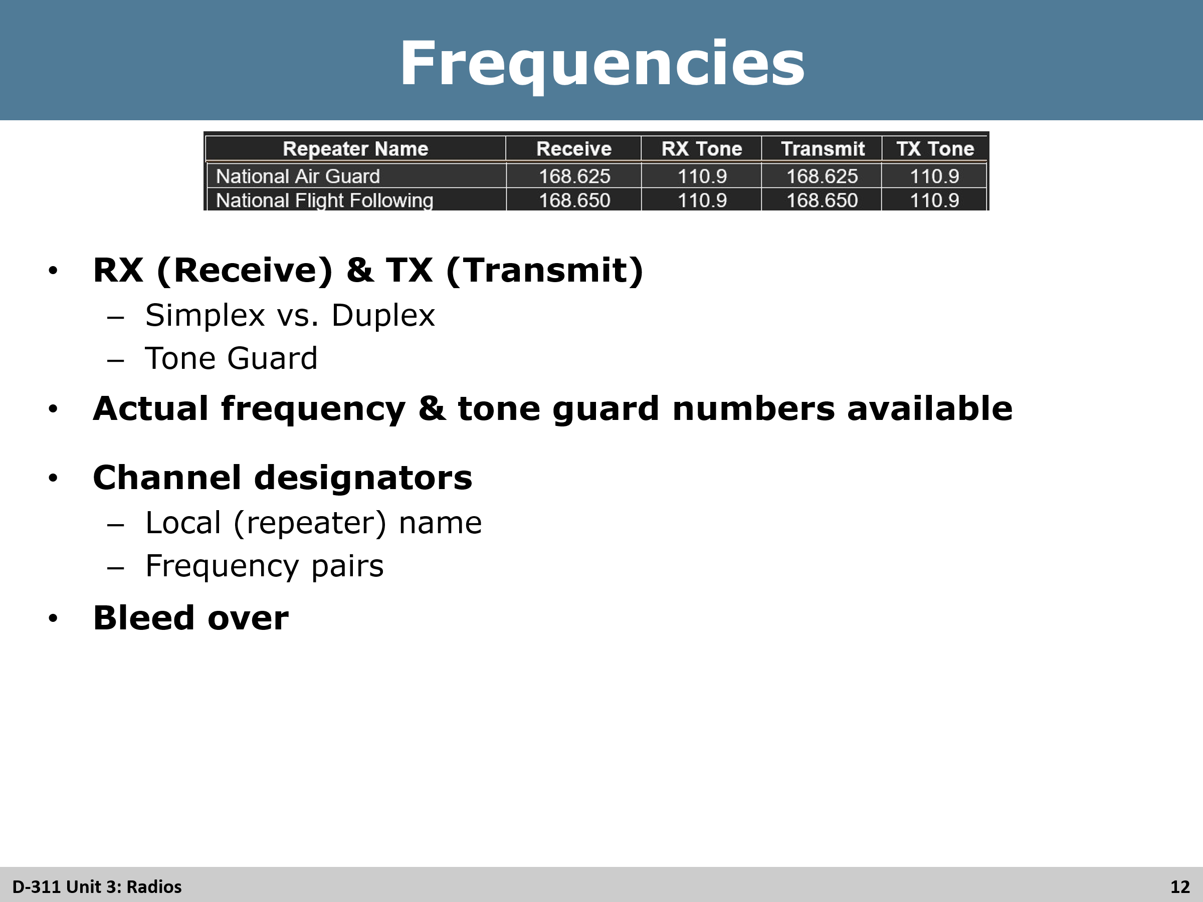
Radio Frequencies
- RX (Receive) & TX (Transmit) Explain what the RX and TX are as well as the differences between simplex and duplex are
  - Simplex – Uses the same frequency to receive and transmit and are also known as direct or car-to-car channels (i.e. Air-to-Ground, Tactical channels)
  - Duplex – Uses more than one frequency with the use of a repeater when two radios cannot talk directly due to distance or terrain. The repeaters will receive on one frequency and transmit on another frequency.
  - Tone Guard – Subaudible signals that are transmitted with the transmit frequency so that a radio can access a repeater. This keeps the repeater from having any outside interference.
- Ensure actual frequency and tone guard numbers are available and correct
- Channel designators
  - Local (repeater) name and tone.
  - Frequency pairs
- Bleed Over
  - Explain bleed over can be caused by another frequency that is similar to the current one being used or that another unit within in a close proximity is using the same frequency
  - Notify supervisors, radio techs, and/or GACC about bleed over. New frequencies may need to be issued to resolve the problem

Slide 13
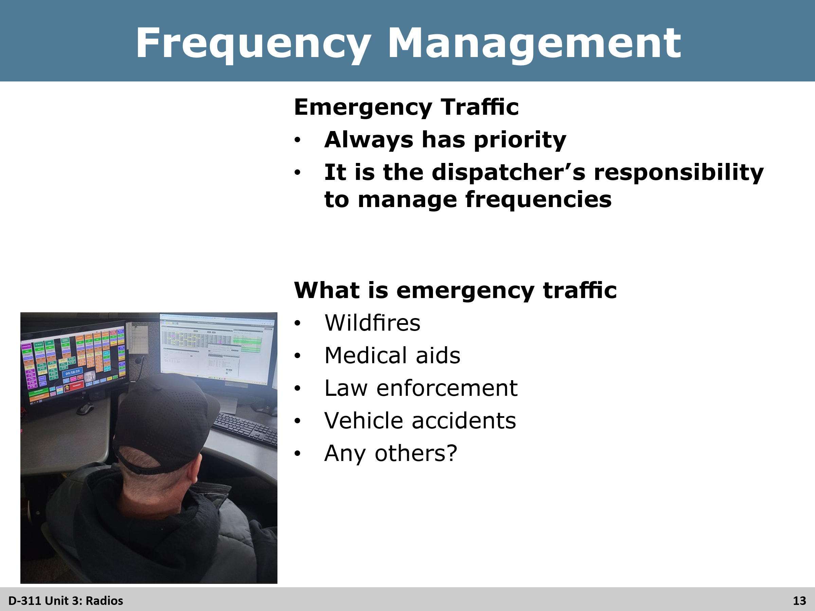
Review
Frequency Management
- Emergency Traffic
  - Always has priority
  - It is the dispatcher’s responsibility to manage frequencies
- What is emergency traffic (have students give examples before showing the common ones)
  - Wildfires
  - Medical aids
  - Law enforcement
  - Vehicle accidents

Slide 14
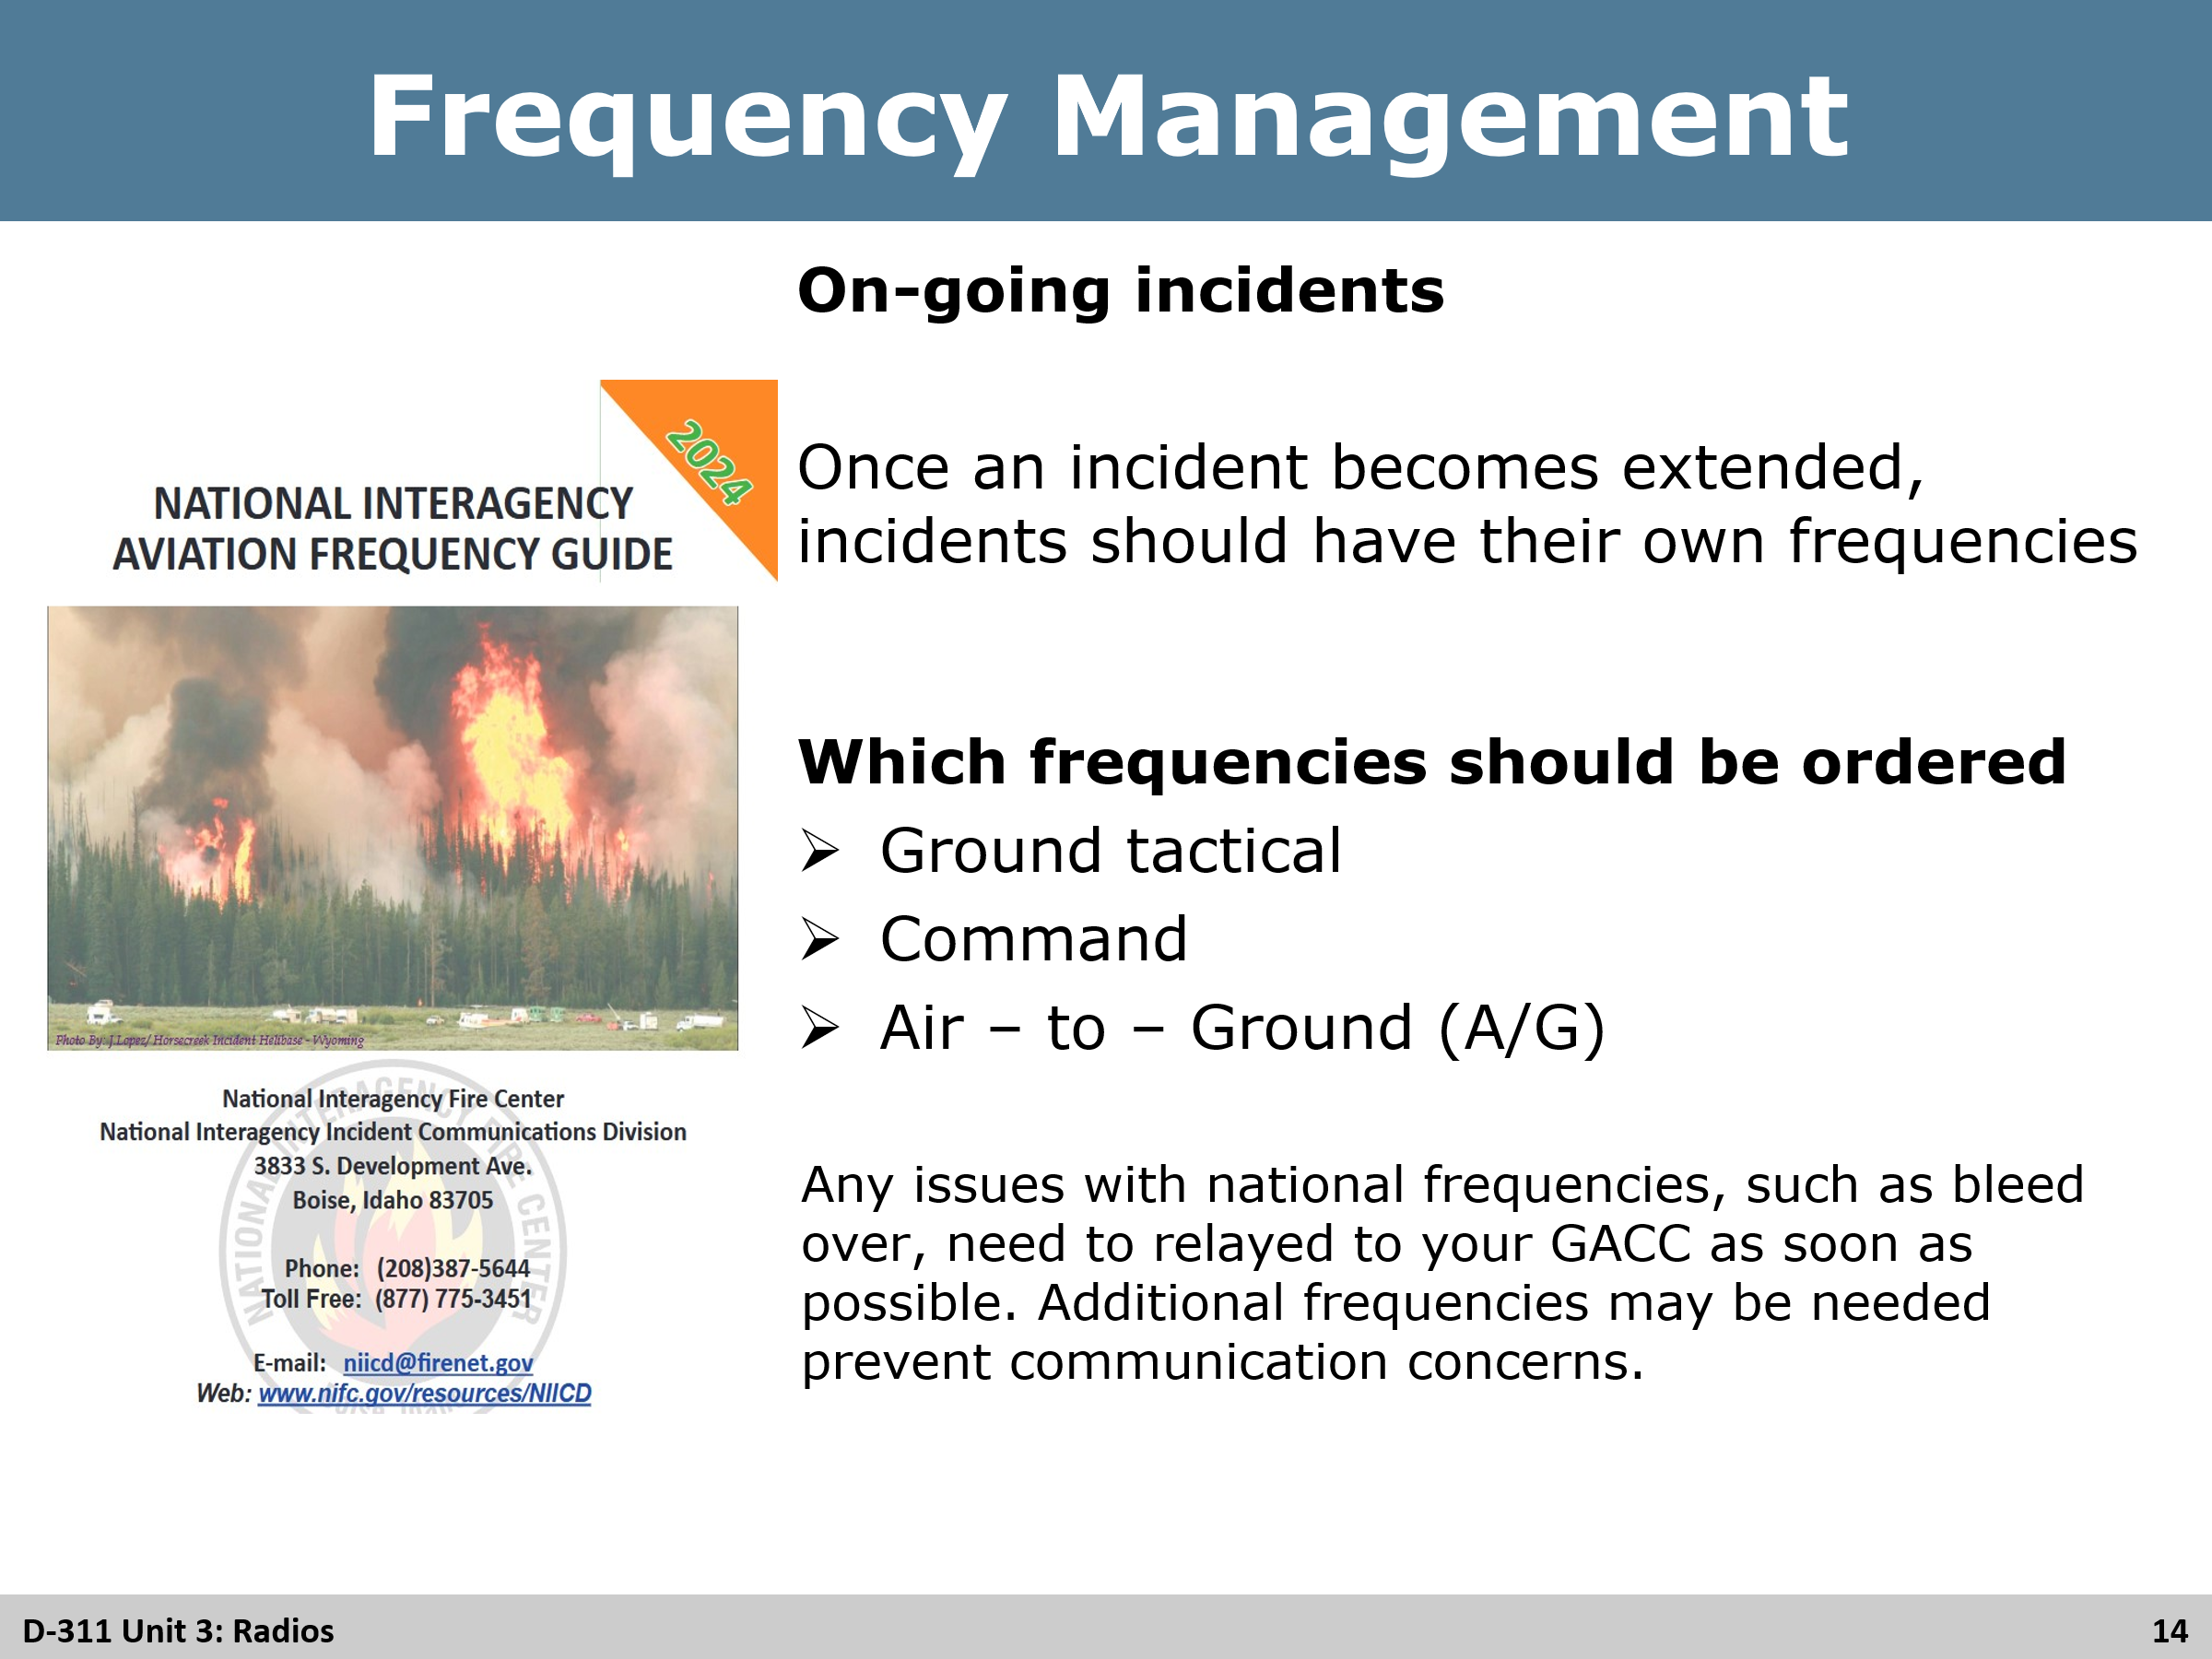
Review
On-going incidents
- Explain the importance of once an incident becomes extended, especially team fires, incidents should have their on frequencies and off the local frequencies.
Which frequencies should be ordered (have the students respond before showing)
- Ground tactical
- Command
- Air-to-Air (A/G)
Again, explain the importance of notification of any frequency issues such as bleed over

Slide 15
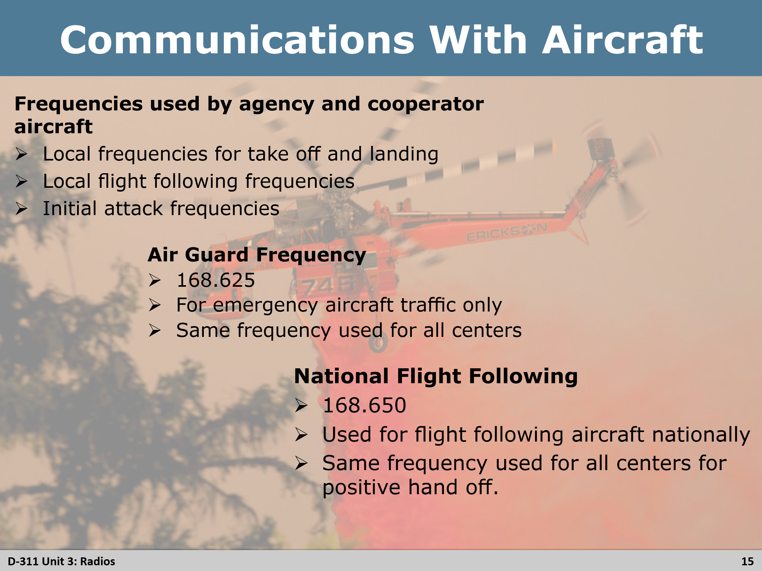
Review
Communications with Aircraft
- Remind students that as an IADP, there will be time they will communicate with aircraft
- Frequencies used by agency and cooperator aircraft
  - Local frequencies for takeoff and landing
  - Local flight following frequencies (some centers have dedicated frequencies specifically for aircraft and local flight following)
  - Initial attack frequencies
- Air Guard Frequency
  - 168.625
  - For emergency aircraft traffic only
  - Same frequency for all centers nation wide
- National Flight Following
  - 168.650
  - Used for flight following nationally, going between dispatch center and geographical boundaries
  - Same frequency used for all centers nationally, for positive hand off from one center to another

Slide 16
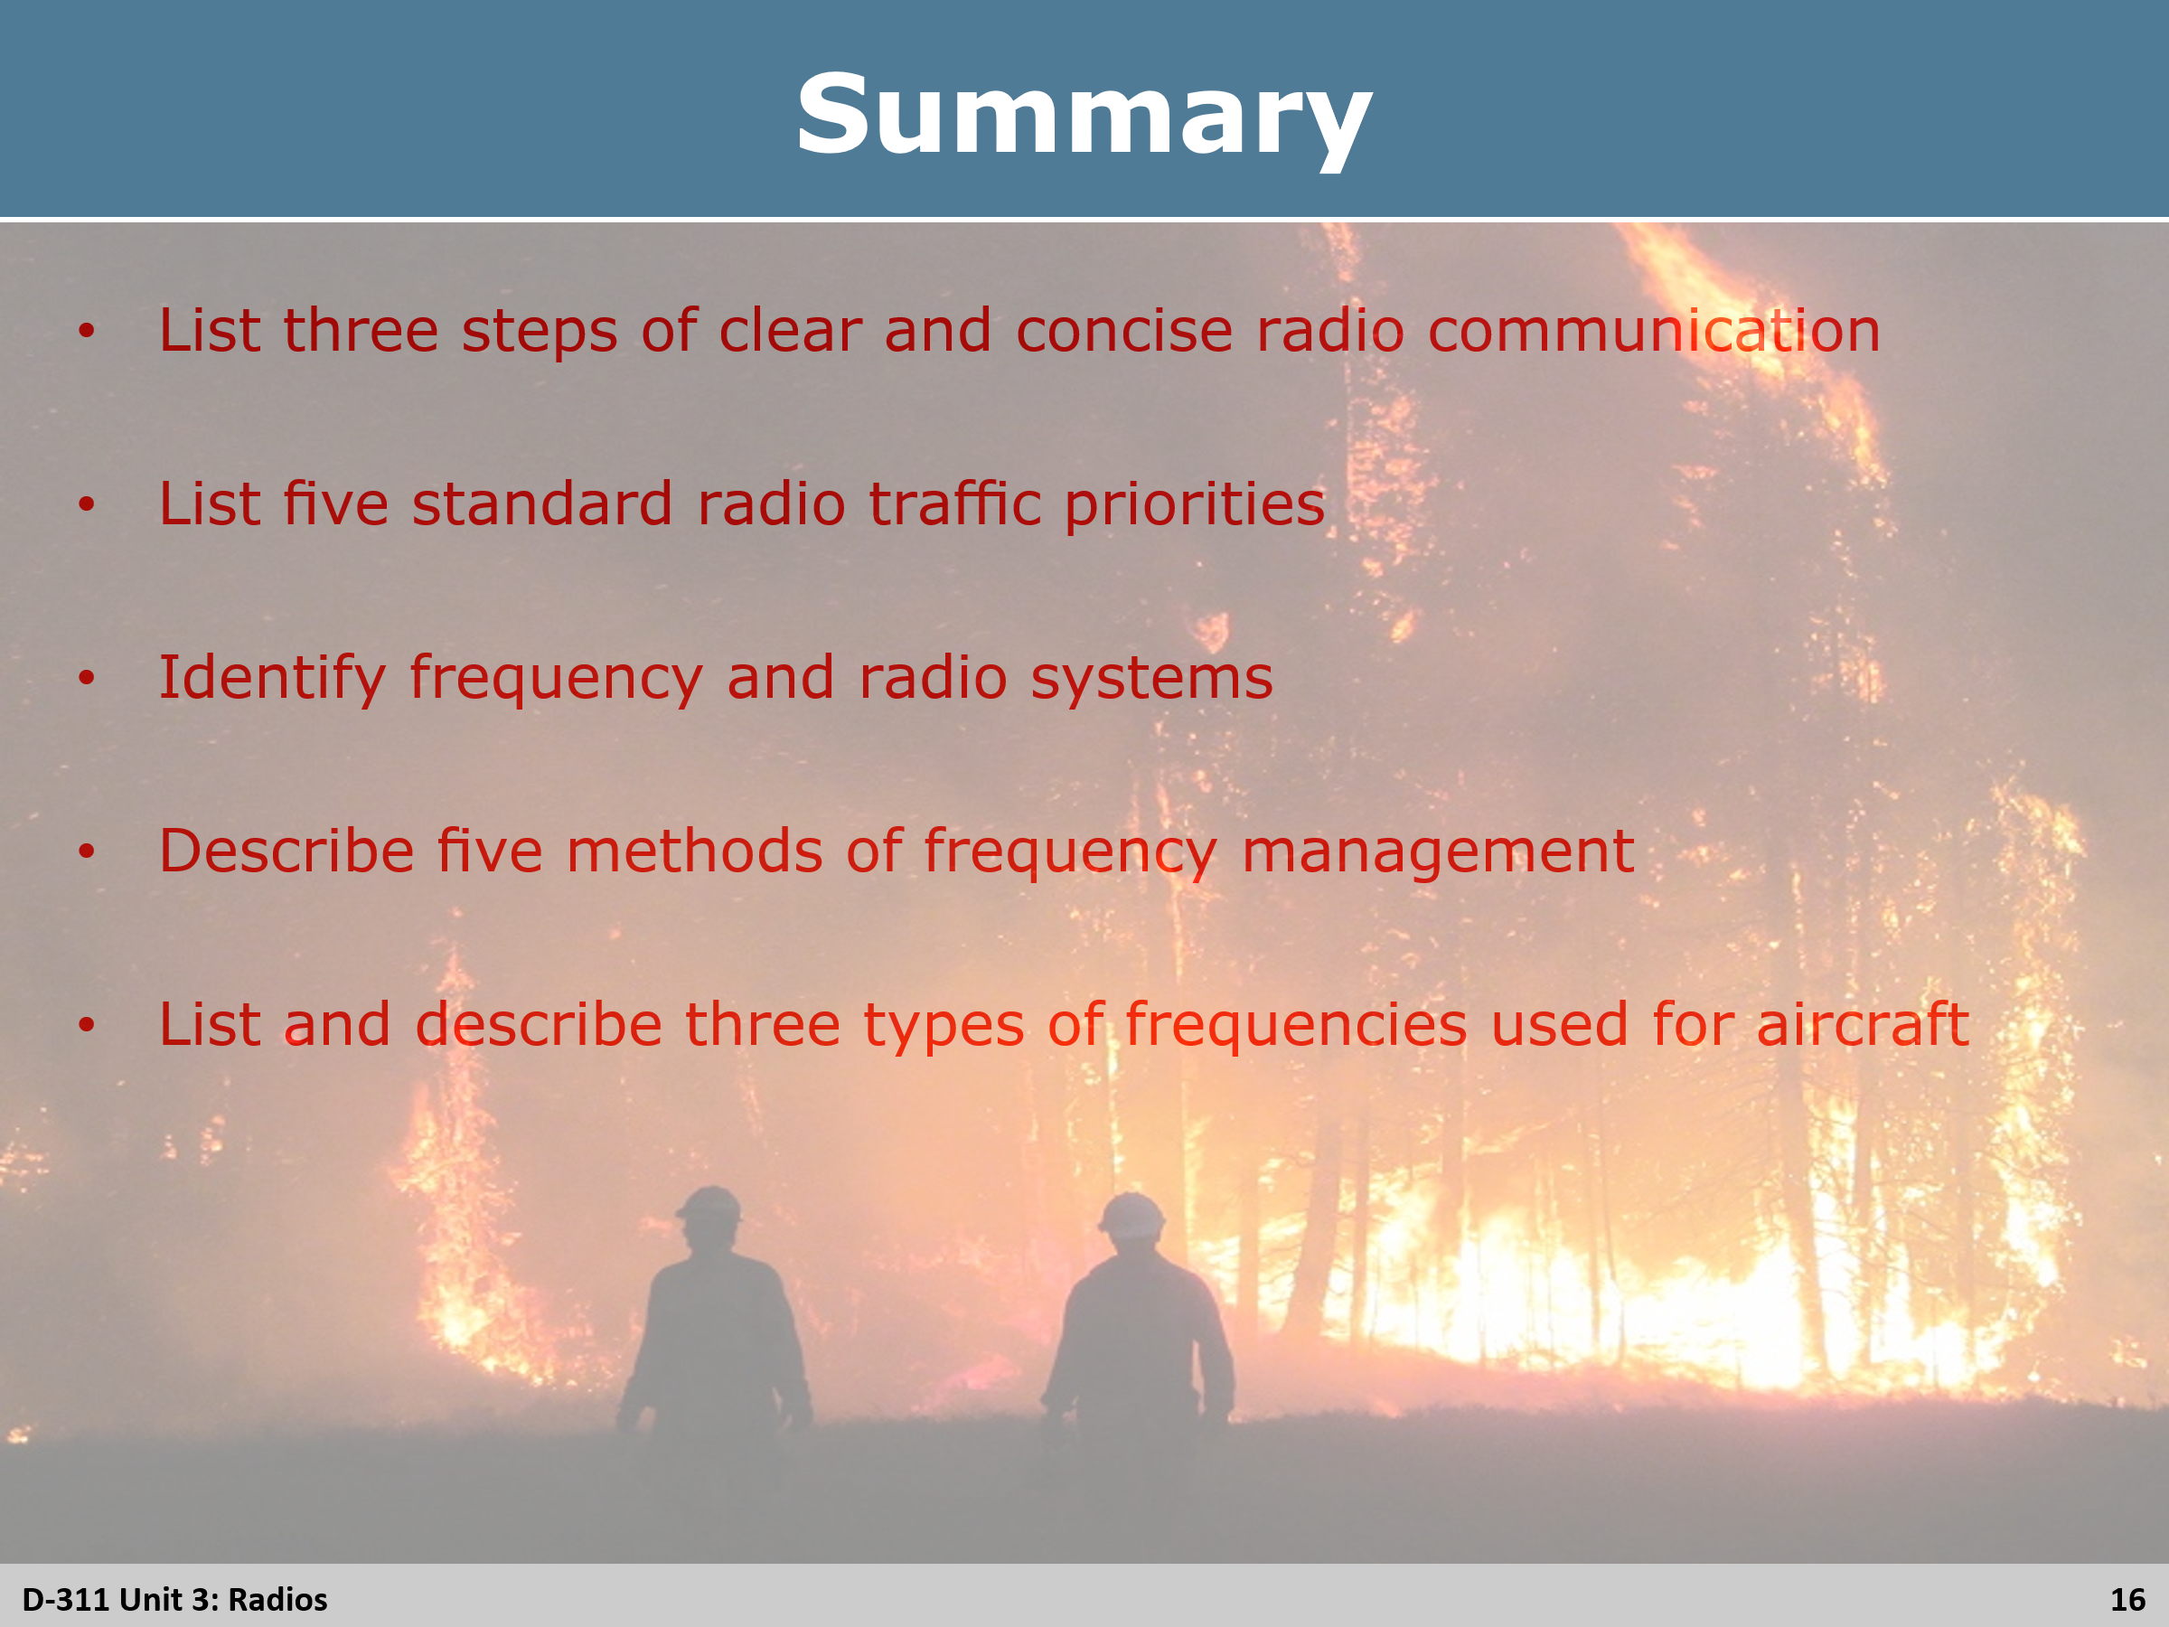
Review
Review the unit objects

